AI LAB ASSIGNMENT 4.3

Saketh

2403a51337

Batch 14

**Task Description#1**

* Zero-shot: Prompt AI to write a function that checks whether a given year is a leap year.

CODE: 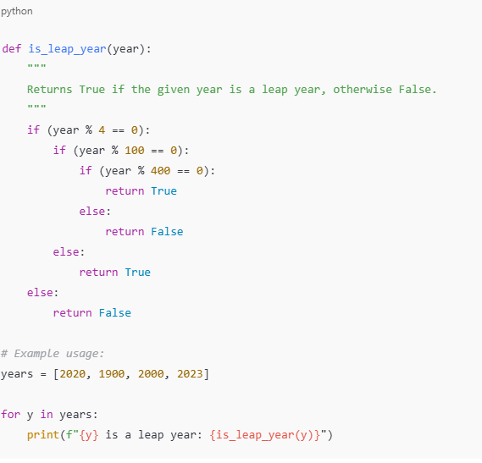

OUTPUT:

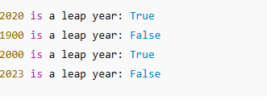

OBSERVATION:

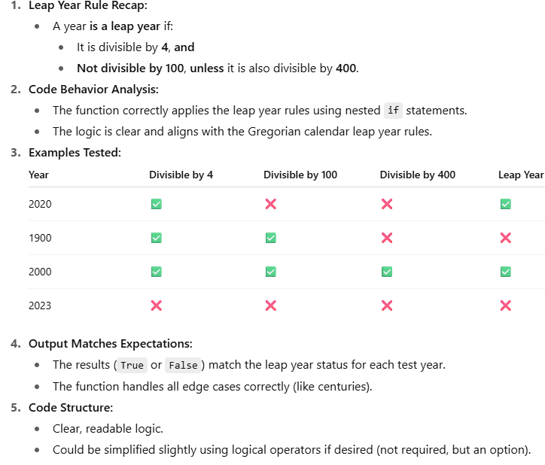

**Task Description#2**

* One-shot: Give one input-output example to guide AI in writing a function that converts centimeters to inches.

CODE:

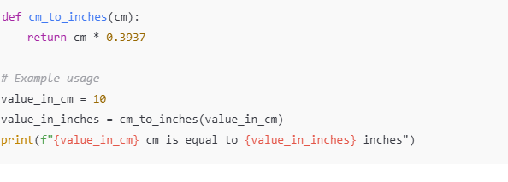

**OUTPUT:**

C:\Users\HP\Pictures\Screenshots\Screenshot 2025-08-20 115332.png

**OBSERVATION:**

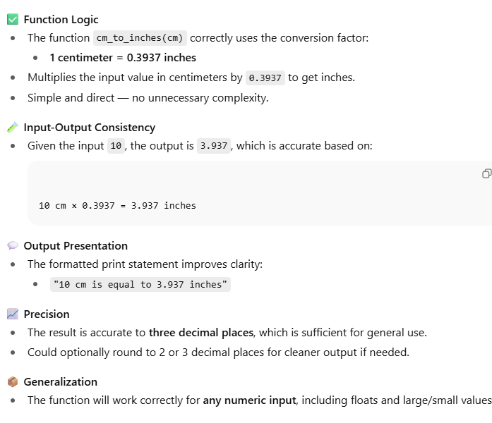

**Task Description#3**

* Few-shot: Provide 2–3 examples to generate a function that formats full names as “Last, First”.

CODE:

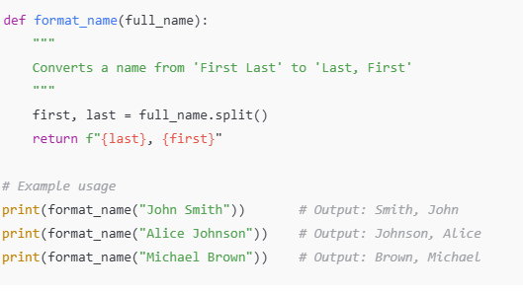

**OUTPUT:**

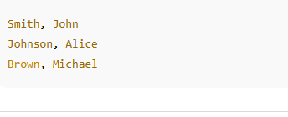

**OBSERVATION:**

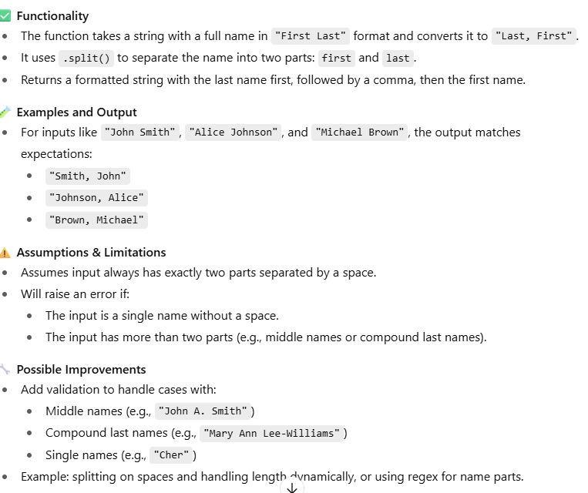

**Task Description#4**

* Compare zero-shot and few-shot prompts for writing a function that counts the number of vowels in a string.

**CODE:**

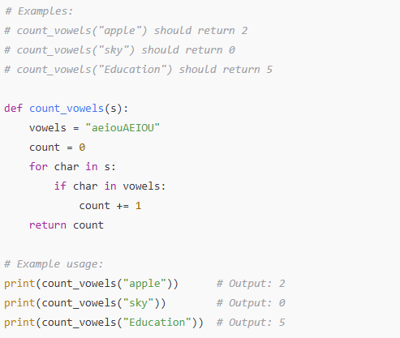

**OUTPUT:**

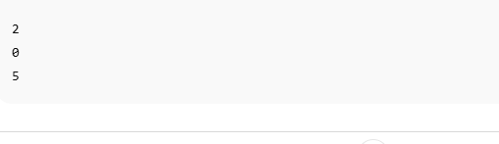

**OBSERVATION:**

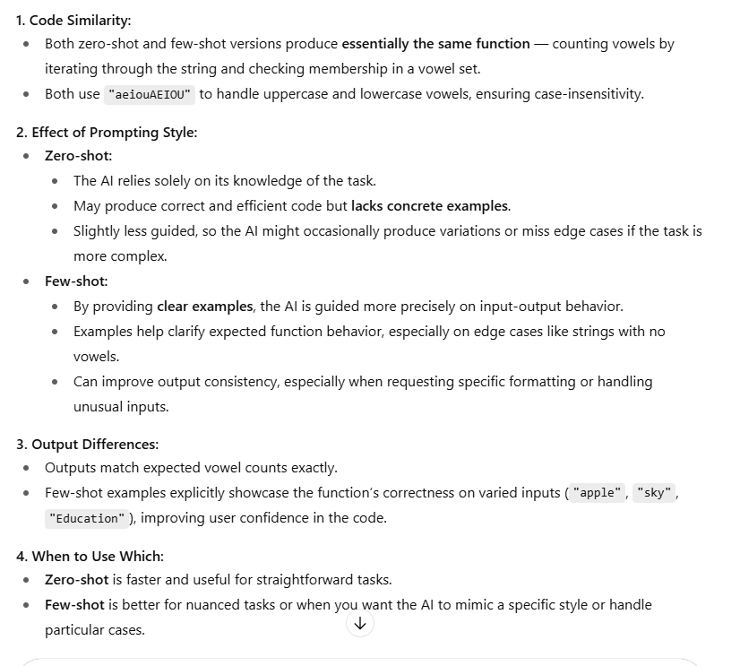

**Task Description#5**

Use few-shot prompting to generate a function that reads a .txt file and returns the number of lines

CODE:

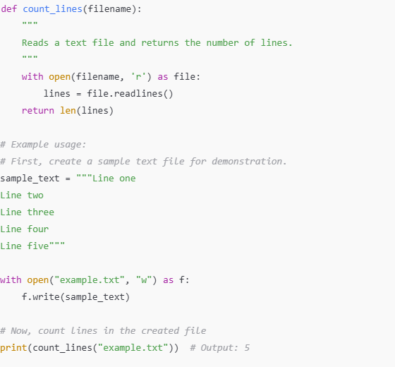

**OUTPUT:**

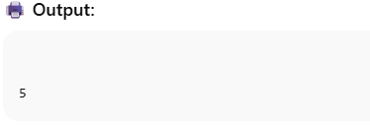

**OBSERVATION:**

